* Built-in Mail Extension for PHP
* SMTP overview
* SMTP in Windos / Linux
* Mail configuration Directives
* Mail Server Authentication
* Fake sendmail for Windows program
* Mail() function
* Web Application Development Version 9.0

SMTP OVERVIEW

* SMTP: Simple Mail Tranfer Protocol is used to send and receive emails
* It is implemented by Mail Transfer Agents (MTA) or as known ‘mail servers’
* Whenever is sent an email (outlook, gmail) your message gets sent to an mail server which relays it to the recipient using SMTP

MAIL CONFIGURATION DIRECTIVES

* php.ini can be configured so that mail() will work i
* In a window the configuration directive SMTP is typically set
* In Linux the configuration directive sendmail_path is typically set

**For Windows**

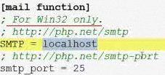

example



**For UNIX uncomment the line**

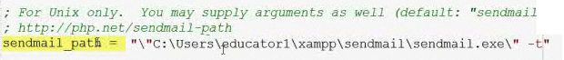

Mail Server Authentication

* For spam concerns, mail servers typically require an email client to authenticate themselves before they will relay their email message to the recipient.
* This authentication can be done several ways, most typically via a username & password and/or by requiring that emails be sent from a computer on the same local network as the mail server
* If configuration in a Windows environment using the SMTP directive doesn’t work because a username and password are required, we can use the ‘fake sendmail’ program provided witn XAMPP

Fake sendmail program

* For windows is an application included with XAMPP the mail() function
* The main ‘add-on’ feature is that for mail servers requiring authentication in order to relay an email via SMTP. ‘fake sendmail’ allows a user to specify a username & password
* The username & password are set in sendmail.ini located in the sendmail directory of the XAMPP installation

**sendmail.ini file**

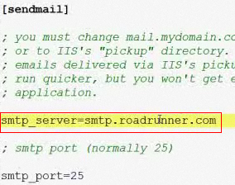

When testing uncomment



For authentication

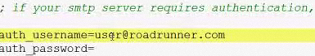

Example

$sent = @mail(‘to@education.com’, ‘Subject’, ‘Message’, ‘From: [from@education.com](mailto:from@education.com)’);

If it worked it returns true

mail.php

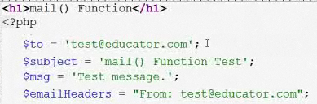

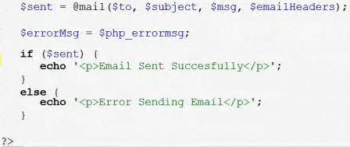

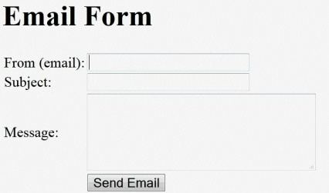

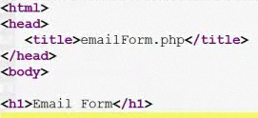

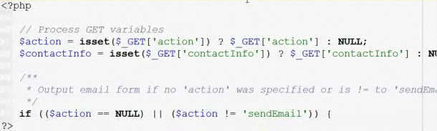

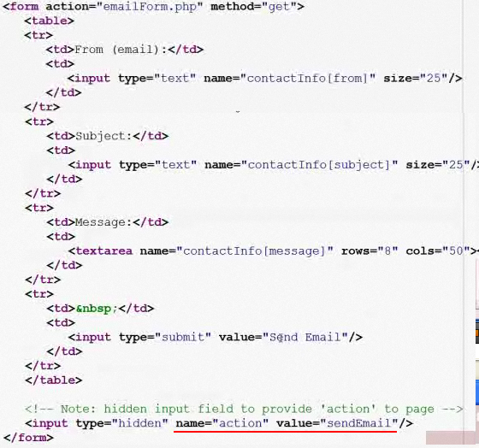

Hidden field to provide action to page

The forms reloads after the email, it calls back emailform.php and check the values

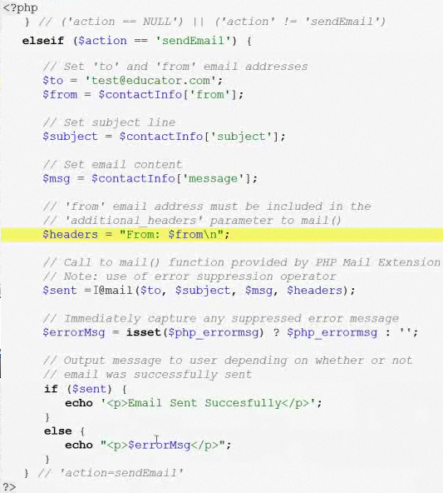

You may use constant variables

config.php

Using 2 contants

